**Experiment No.: 03**

**Aim:** Write a program to implement logical AND using the Perceptron network

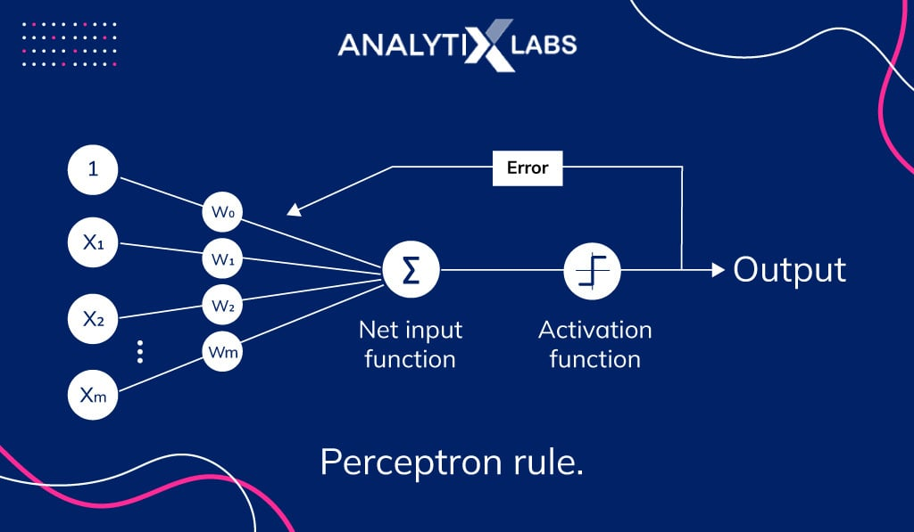

**Steps:**

1. **Initialization:**
   * Initialize weights (**w1** and **w2**) and bias (**bias**) to some values (provided as arguments to the function).
   * Define the input pairs **xi** for the logical AND operation.
2. **Iterate through Input Pairs:**
   * For each input pair **(x[0], x[1])** in **xi**:
     + Calculate the linear combination of inputs and weights:

**linear_combination = w1 * x[0] + w2 * x[1] + bias**.

* + - Determine the output based on a threshold:

**output = 1 if linear_combination >= threshold else 0**.

* + - Set the target output as the logical AND of the inputs: **target_output = x[0] * x[1]**.

**Weight Update:**

If the output does not match the target output:

* + - Update weights using the perceptron learning rule:
      * **w1 = w1 + learning_rate * (target_output - output) * x[0]**
      * **w2 = w2 + learning_rate * (target_output - output) * x[1]**
    - Clear the **outputs** list to start fresh for the next iteration.
    - Recursively call the **cal_output_and** function with updated weights to continue the learning process.

1. **Output Results:**
   * Store the results (inputs, linear combination, and activation output) in a DataFrame for visualization.
   * Print the results, including weights and learning rate.

**Code:**

import numpy as np

import pandas as pd

def cal_output_and(w1, w2, learning_rate, threshold=1):

bias = 0

xi = [(0, 0), (0, 1), (1, 0), (1, 1)]

outputs = []

for x in xi:

linear_combination = w1 * x[0] + w2 * x[1] + bias

output = int(linear_combination >= threshold)

target_output = x[0] * x[1]

if output != target_output:

w1 = w1 + learning_rate * (target_output - output) * x[0]

w2 = w2 + learning_rate * (target_output - output) * x[1]

outputs = [] # Clear outputs when weights are updated

cal_output_and(w1, w2, learning_rate)

return

outputs.append([x[0], x[1], linear_combination, output])

output_frame = pd.DataFrame(outputs, columns=['Input 1', 'Input 2', 'Linear Combination', 'Activation Output'])

print(f'Results for threshold: {threshold} \n')

print(f'Results for w1: {w1} \n')

print(f'Results for w2: {w2} \n')

print(f'Results for learning_rate: {learning_rate} \n')

print(output_frame.to_string(index=False))

w1 = 1.2

w2 = 0.6

learning_rate = 0.5

cal_output_and(w1, w2, learning_rate)

**Output:**

